Exercise 1

Q1. Create a simple HTML page using basic tags.

**Code:**

<!DOCTYPE html>

<html>

<head>

<title>Simple HTML Page</title>

</head>

<body>

<h1>Welcome to My First HTML Page</h1>

<p>This is a simple HTML page with basic tags.</p>

</body>

</html>

**Output:**

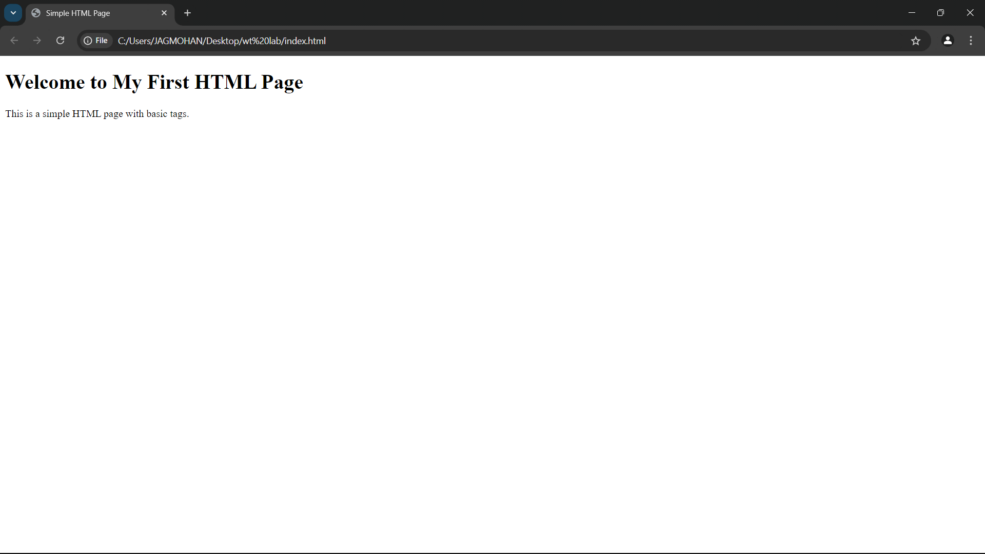

Exercise 2

Q2. Create a web page that displays your name to the screen.

**Code:**

<!DOCTYPE html>

<html>

<head>

<title>Display Name</title>

</head>

<body>

<h1>Dev Arora</h1>

</body>

</html>

**Output:**

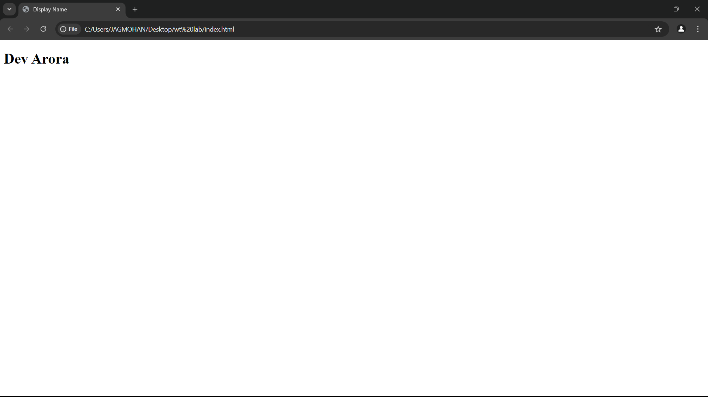

Exercise 3

Q3. Create a web page and show the output from 1 to 10 in separate lines.

**Code:**

<!DOCTYPE html>

<html>

<head>

<title>Numbers 1 to 10</title>

</head>

<body>

<p>1</p>

<p>2</p>

<p>3</p>

<p>4</p>

<p>5</p>

<p>6</p>

<p>7</p>

<p>8</p>

<p>9</p>

<p>10</p>

</body>

</html>

**Output:**

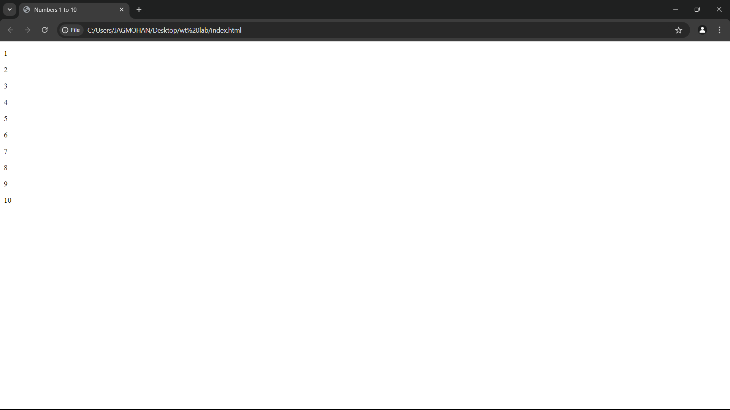

Exercise 4

Q4. Create a web page and show the output from 1 to 10 in separate lines, each number being in different color.

**Code:**

<!DOCTYPE html>

<html>

<head>

<title>Colored Numbers</title>

</head>

<body>

<p style="color:red;">1</p>

<p style="color:blue;">2</p>

<p style="color:green;">3</p>

<p style="color:orange;">4</p>

<p style="color:purple;">5</p>

<p style="color:pink;">6</p>

<p style="color:yellow;">7</p>

<p style="color:cyan;">8</p>

<p style="color:brown;">9</p>

<p style="color:gray;">10</p>

</body>

</html>

**Output:**

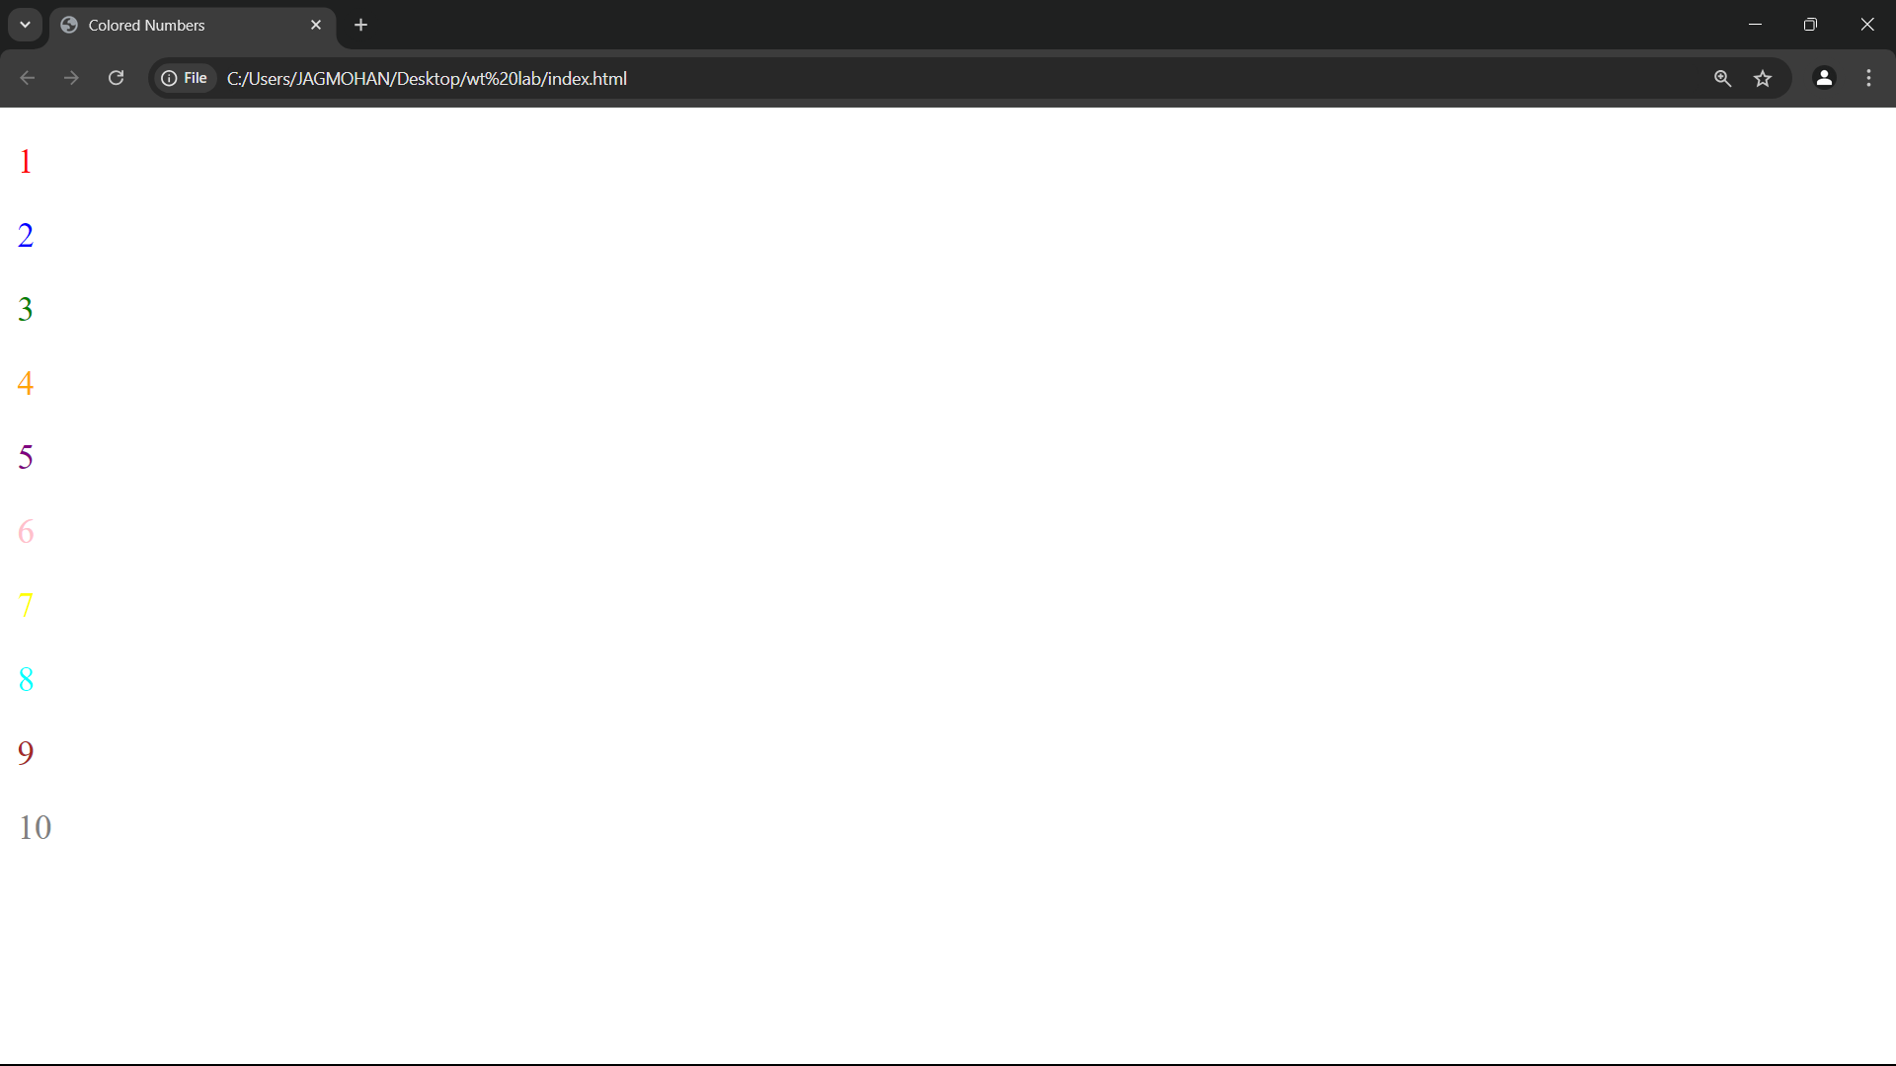

Exercise 5

Q5. How do I make a picture as a background on my web pages?

**Code :**

<!DOCTYPE html>

<html>

<head>

<title>Background Image</title>

<style>

body {

background-image: url("dev.jpg");

background-size: cover;

}

</style>

</head>

<body>

<h1>Background Image Example</h1>

</body>

</html>

**Output:**

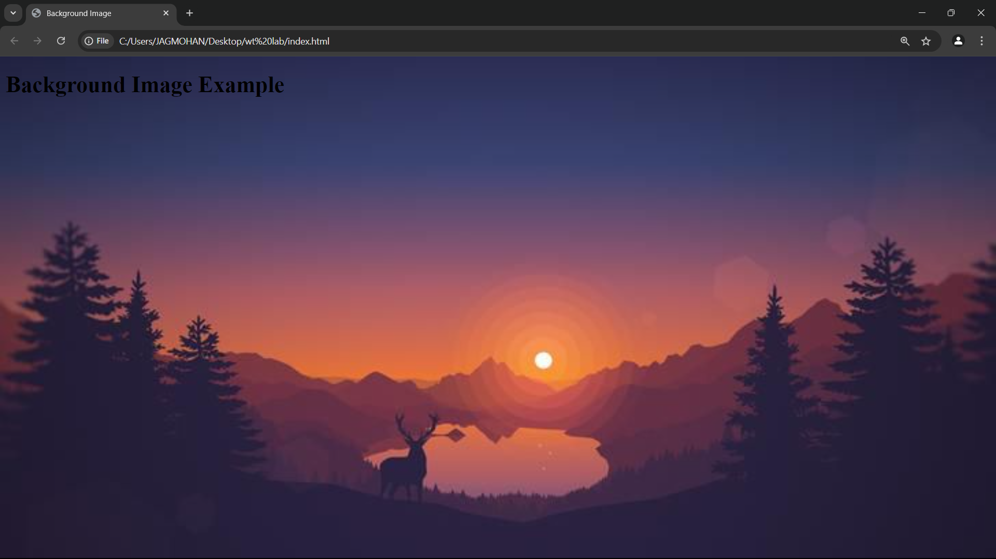

Exercise 6

Q6. Create a web page to print a paragraph with 4-5 sentences, each sentence shall have a different font.

**Code :**

<!DOCTYPE html>

<html>

<head>

<title>Different Fonts</title>

</head>

<body>

<p style="font-family: Arial;">This is the first sentence in Arial font.</p>

<p style="font-family: Verdana;">This is the second sentence in Verdana font.</p>

<p style="font-family: Courier;">This is the third sentence in Courier font.</p>

<p style="font-family: Georgia;">This is the fourth sentence in Georgia font.</p>

</body>

</html>

**Output :**

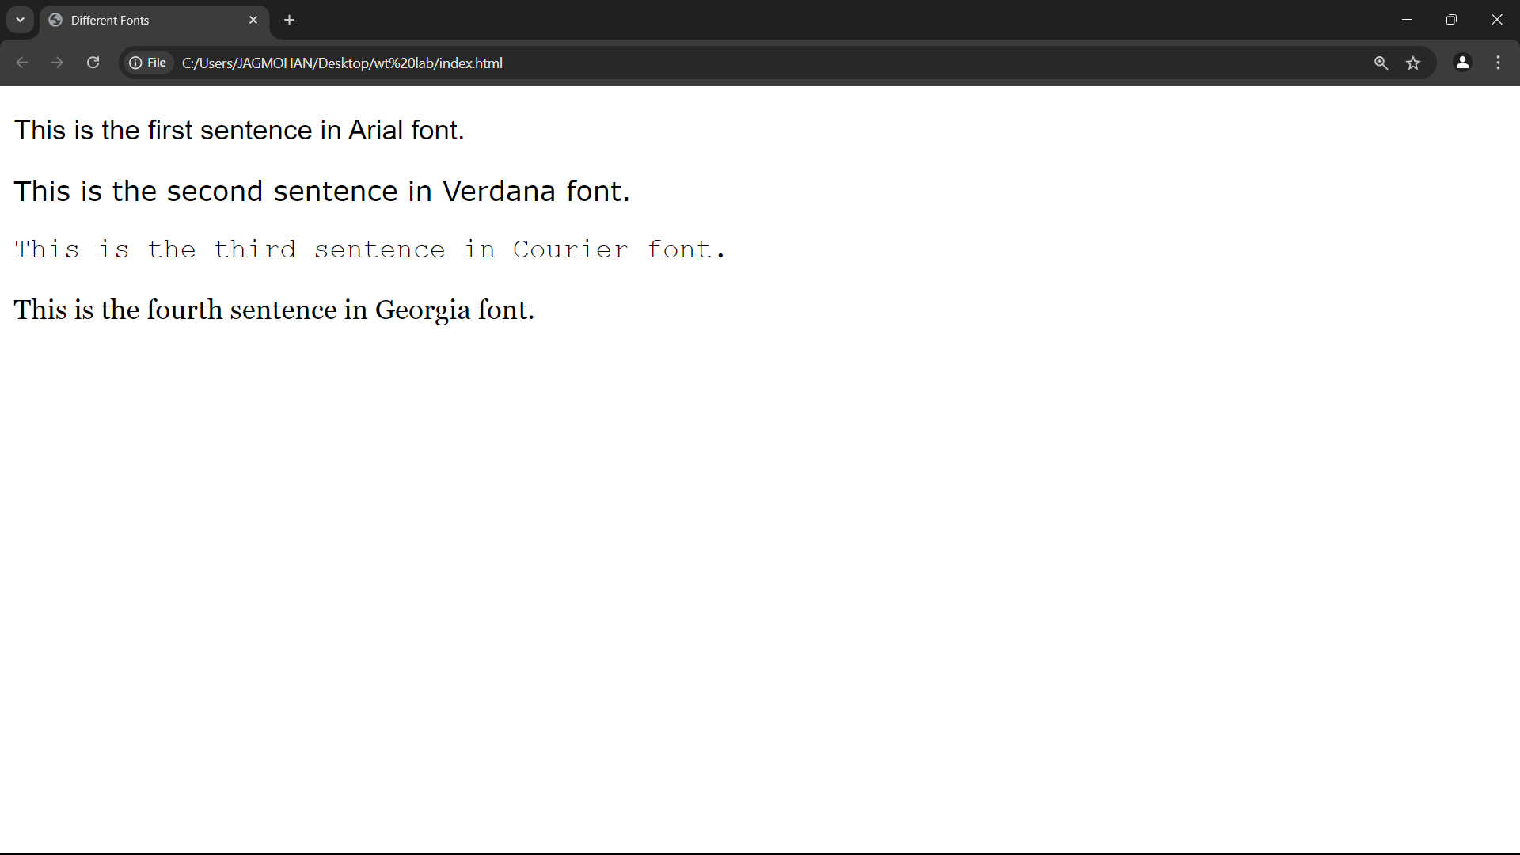

Exercise 7

Q7. Write HTML code to print a paragraph that describes a book. Title should be underlined, adjectives bold and italicized.

Code :

<!DOCTYPE html>

<html>

<head>

<title>Book Description</title>

</head>

<body>

<p>

The book <u>The Great Adventure</u> by John Doe is a <b><i>thrilling</i></b> and <b><i>exciting</i></b> story about a group of explorers.

</p>

</body>

</html>

**Output :**

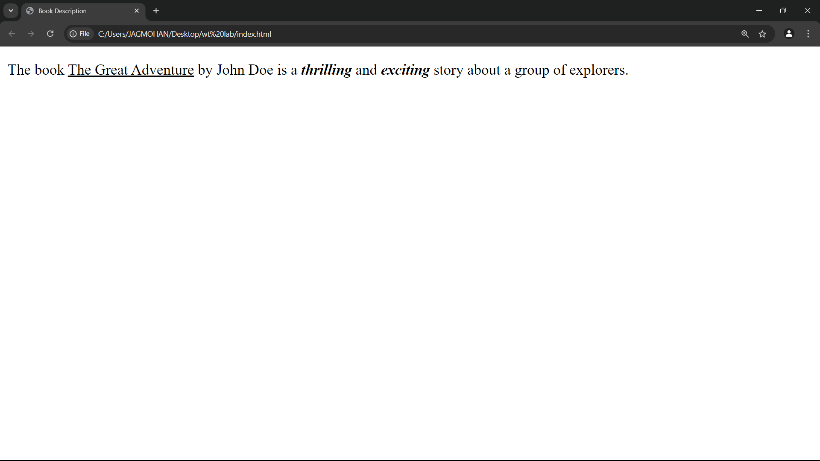

Exercise 8

Q8. Write HTML code to print your name using Heading tag, every letter shall be of different heading size.

Code :

<!DOCTYPE html>

<html>

<head>

<title>Heading Name</title>

</head>

<body>

<h1>D</h1>

<h2>E</h2>

<h3>v</h3>

<h4>A</h4>

<h5>R</h5>

<h6>O</h6>

<h6>R</h6>

<h6>A</h6>

</body>

</html>

**Output :**

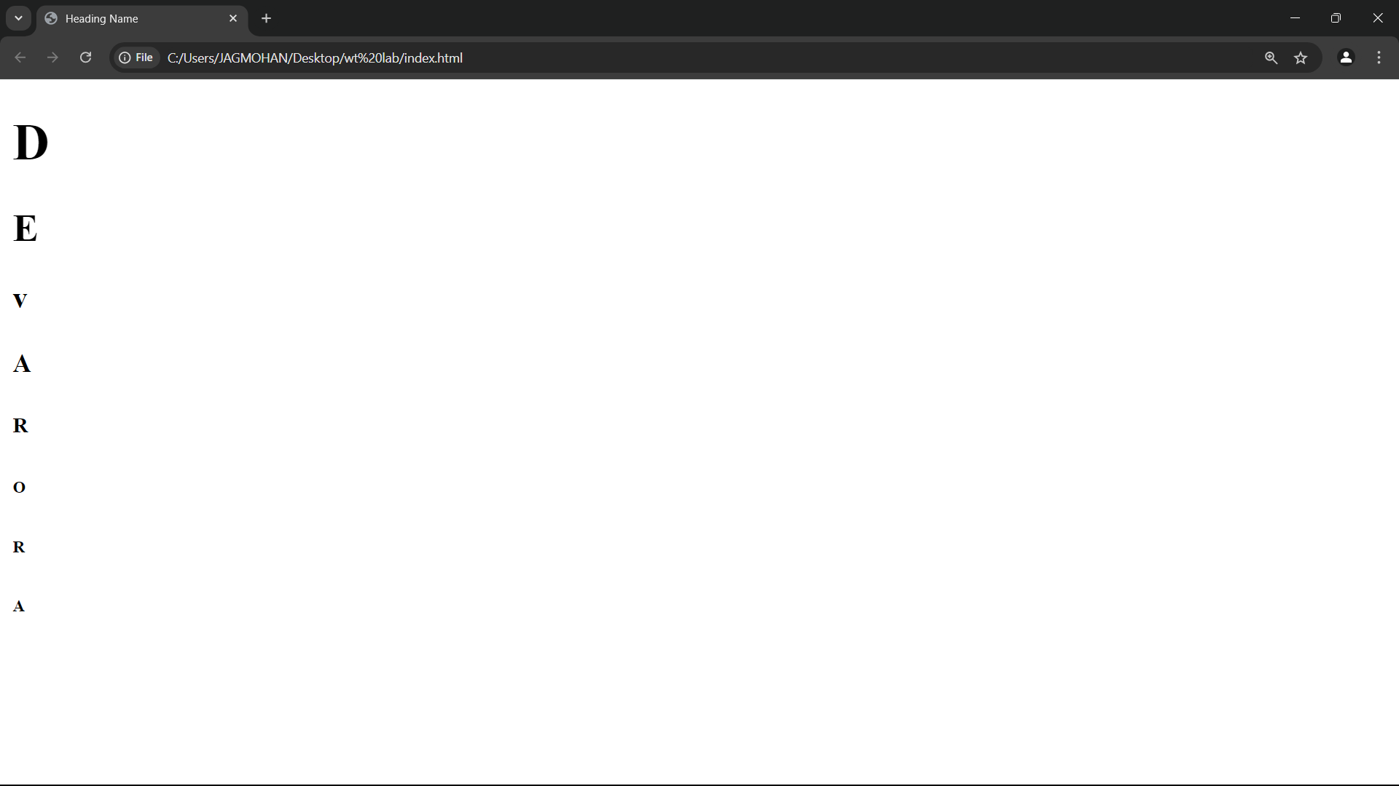

Exercise 9

Q9. Write HTML code to print the sequence of numbers 1-20, each number in a different line with number 2 as subscript.

Code :

<!DOCTYPE html>

<html>

<head>

<title>Sequence of Numbers</title>

</head>

<body>

<p>1</p>

<p>2<sub>2</sub> = 4</p>

<p>3</p>

<p>4</p>

<p>5</p>

<p>6</p>

<p>7</p>

<p>8</p>

<p>9</p>

<p>10</p>

<p>11</p>

<p>12</p>

<p>13</p>

<p>14</p>

<p>15</p>

<p>16</p>

<p>17</p>

<p>18</p>

<p>19</p>

<p>20</p>

</body>

</html>

**Output :**

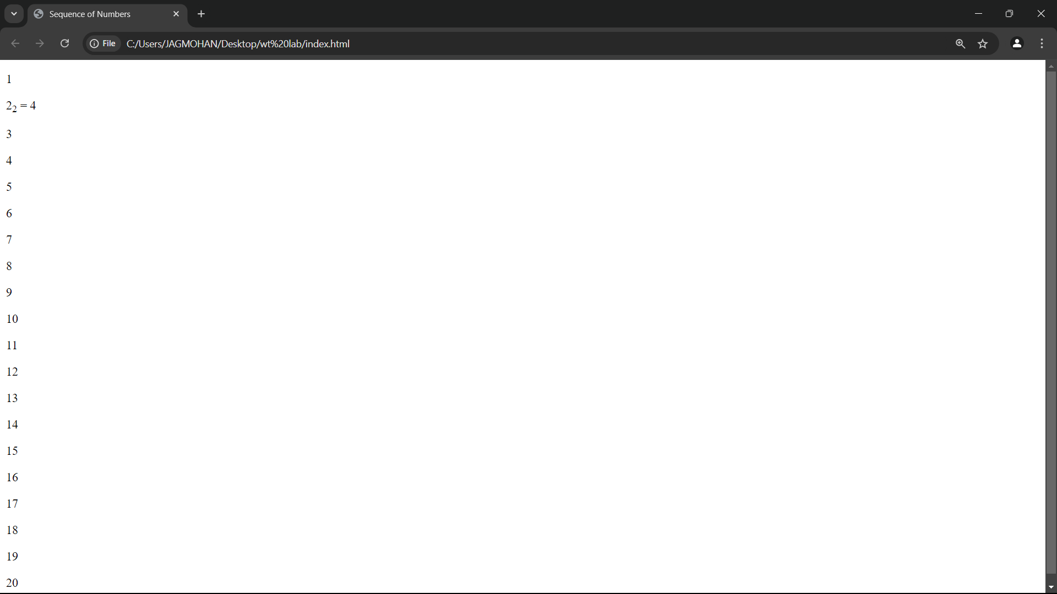

Exercise 10

10. Write HTML code to display an image with border size 200x200 pixels, Hspace and Vspace of choice.

**Code :**

<!DOCTYPE html>

<html>

<head>

<title>Image with Border</title>

</head>

<body>

<img src="images (1).jpeg" width="200" height="200" style="border: 2px solid black; margin: 20px; float: right;">

</body>

</html>

**Output :**

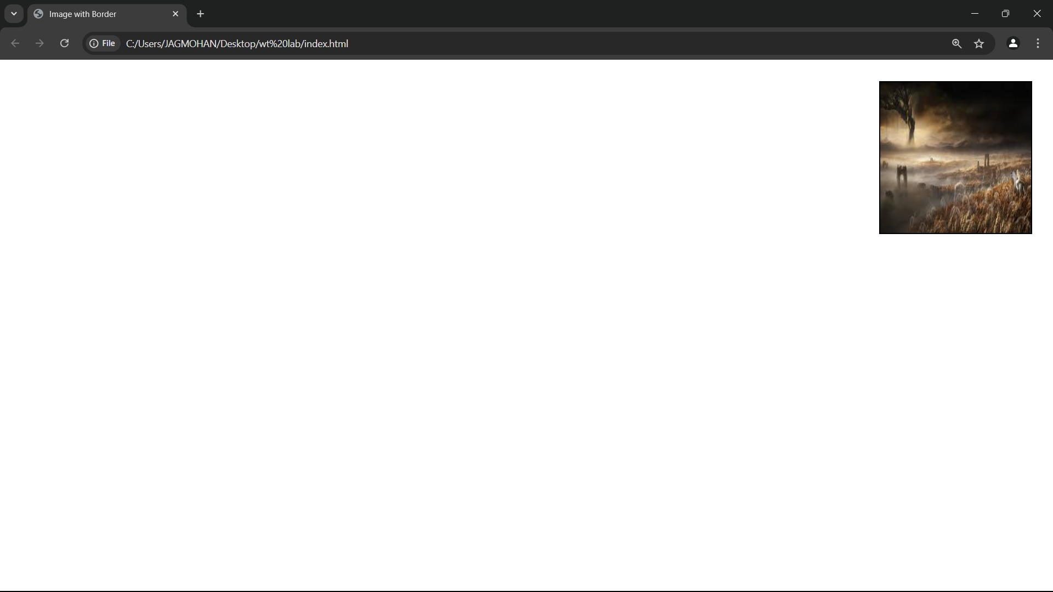

Exercise 11

11. Write HTML code to create a web page with heading. The heading shall be displayed at the top-center of the page and the image shall be at the center, just below the heading.

**Code :**

<!DOCTYPE html>

<html lang="en">

<head>

<meta charset="UTF-8">

<meta name="viewport" content="width=device-width, initial-scale=1.0">

<title>Centered Heading and Image</title>

<style>

body {

text-align: center;

}

img {

margin-top: 20px;

}

</style>

</head>

<body>

<h1>Welcome to My Web Page</h1>

<!-- Image with local path (corrected for browser) -->

<img src="file:///C:/Users/chaha/Downloads/R.jpg" alt="Example Image" width="300">

</body>

</html>

**Output :**

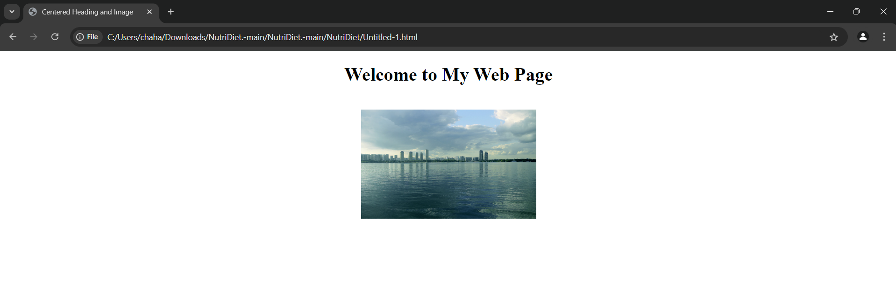

Exercise 12

12. Write HTML code using Multimedia tags.

**Code :**

<!DOCTYPE html>

<html lang="en">

<head>

<meta charset="UTF-8">

<meta name="viewport" content="width=device-width, initial-scale=1.0">

<title>Multimedia Example</title>

</head>

<body>

<h1>Multimedia Demo</h1>

<!-- Video with local file path -->

<video controls width="320">

<source src="file:///C:/Users/chaha/Downloads/of%20the%20day.mp4" type="video/mp4">

Your browser does not support the video tag.

</video>

<!-- Audio with local file path -->

<audio controls>

<source src="C:\Users\chaha\Downloads\Game On.mp3" type="audio/mpeg">

Your browser does not support the audio tag.

</audio>

</body>

</html>

**Output :**

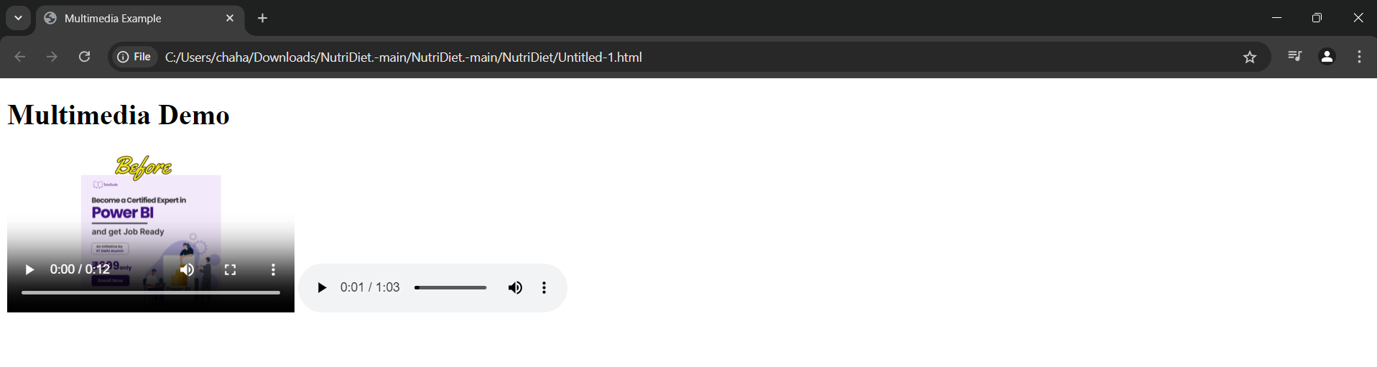

Exercise 13

13. Create a Table using Rowspan and Colspan taking example of student Record..

**Code :**

<!DOCTYPE html>

<html lang="en">

<head>

<meta charset="UTF-8">

<meta name="viewport" content="width=device-width, initial-scale=1.0">

<title>Student Record Table</title>

</head>

<body>

<table border="1">

<tr>

<th rowspan="2">Roll No</th>

<th rowspan="2">Name</th>

<th colspan="3">Marks</th>

</tr>

<tr>

<th>Math</th>

<th>Science</th>

<th>English</th>

</tr>

<tr>

<td>1</td>

<td>John</td>

<td>85</td>

<td>90</td>

<td>88</td>

</tr>

</table>

</body>

</html>

**Output :** 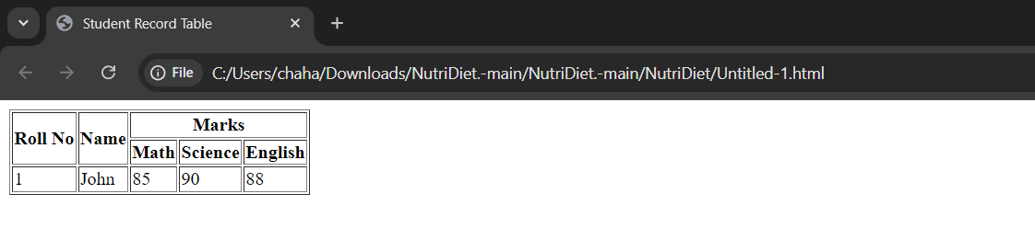

Exercise 14

14. Write HTML code using table tag <table> and cellpadding and cellspacing as its attributes..

**Code :**

<!DOCTYPE html>

<html lang="en">

<head>

<meta charset="UTF-8">

<meta name="viewport" content="width=device-width, initial-scale=1.0">

<title>Table Example</title>

</head>

<body>

<table border="1" cellpadding="10" cellspacing="5">

<tr>

<th>Name</th>

<th>Age</th>

</tr>

<tr>

<td>Alice</td>

<td>24</td>

</tr>

<tr>

<td>Bob</td>

<td>30</td>

</tr>

</table>

</body>

</html>

**Output :** 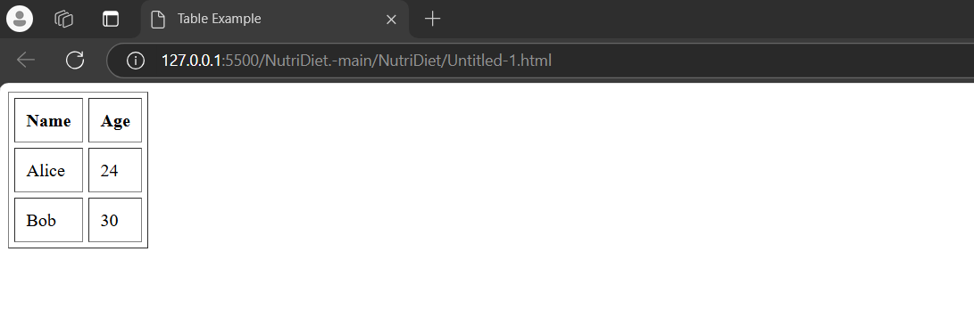

Exercise 15

15. Create unordered, ordered and definition Lists taking example of your subjects in MCA IST, IInd and IIIrd Semester.

**Code :**

<!DOCTYPE html>

<html lang="en">

<head>

<meta charset="UTF-8">

<meta name="viewport" content="width=device-width, initial-scale=1.0">

<title>Lists Example</title>

</head>

<body>

<h2>Ordered List</h2>

<ol>

<li>Database</li>

<li>Networking</li>

<li>Web Development</li>

</ol>

<h2>Unordered List</h2>

<ul>

<li>Programming</li>

<li>Mathematics</li>

<li>Physics</li>

</ul>

<h2>Definition List</h2>

<dl>

<dt>HTML</dt>

<dd>HyperText Markup Language</dd>

<dt>CSS</dt>

<dd>Cascading Style Sheets</dd>

</dl>

</body>

</html>

**Output :** 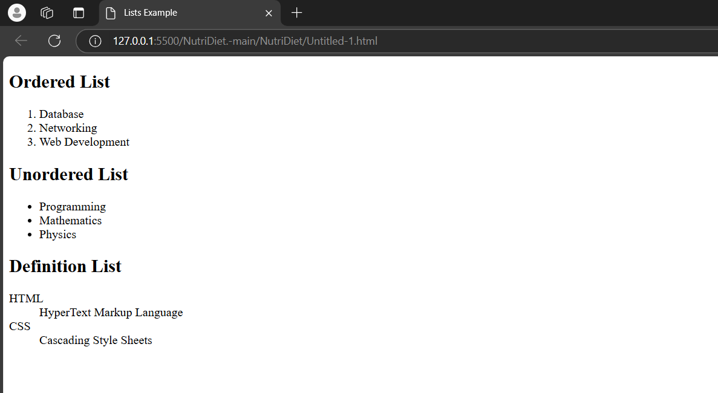

Exercise 16

16. Write HTML code using <frameset> and <frame> tag with all its attributes

**Code :**

**Output :**

Exercise 17

17. Write HTML code to design a form in HTML using controls and buttons such as Teaxtbox, Textarea,password, submit button, browse button, drop-down menu

**Code :**

<!DOCTYPE html>

<html>

<head>

<title>Form Example</title>

</head>

<body>

<form>

<label for="name">Name:</label>

<input type="text" id="name" name="name"><br><br>

<label for="password">Password:</label>

<input type="password" id="password" name="password"><br><br>

<label for="comments">Comments:</label><br>

<textarea id="comments" name="comments"></textarea><br><br>

<label for="gender">Gender:</label>

<select id="gender" name="gender">

<option>Male</option>

<option>Female</option>

</select><br><br>

<label for="file">Upload File:</label>

<input type="file" id="file" name="file"><br><br>

<input type="submit" value="Submit">

</form>

</body>

</html>

**Output :** 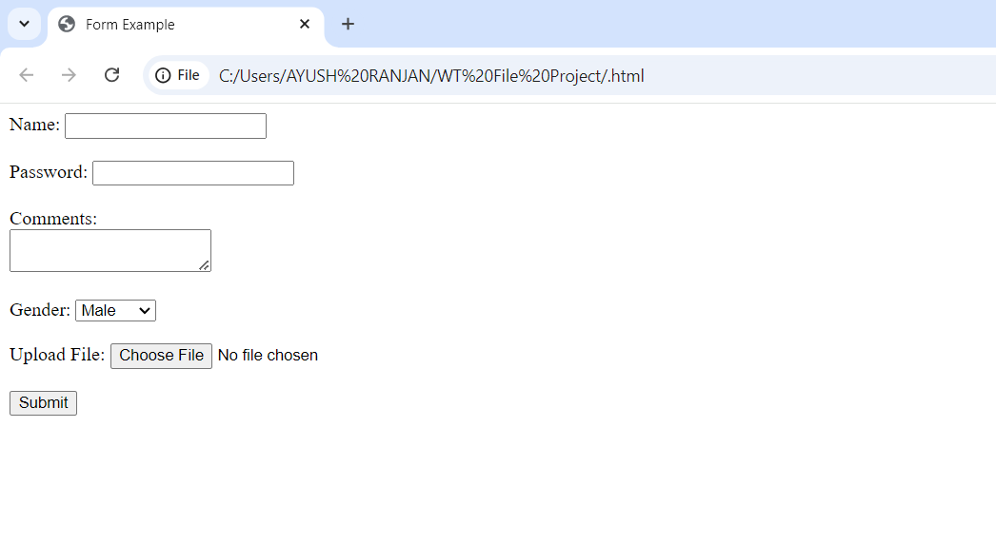

Exercise 18

18. Write HTML code to design a Registration Form in HTML.

**Code :**

<!DOCTYPE html>

<html>

<head>

<title>Registration Form</title>

</head>

<body>

<form>

<h1>Registration Form</h1>

<label for="username">Username:</label>

<input type="text" id="username" name="username"><br><br>

<label for="email">Email:</label>

<input type="email" id="email" name="email"><br><br>

<label for="password">Password:</label>

<input type="password" id="password" name="password"><br><br>

<input type="submit" value="Register">

</form>

</body>

</html>

**Output :** 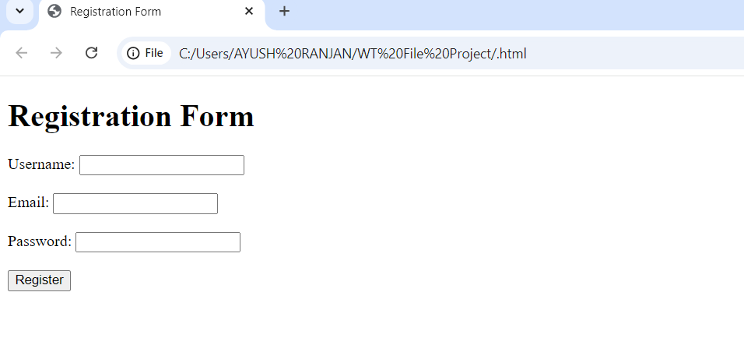

Exercise 19

19. Write HTML code to design a student admission Form in HTML.

**Code :**

<!DOCTYPE html>

<html>

<head>

<title>Admission Form</title>

</head>

<body>

<form>

<h1>Student Admission Form</h1>

<label for="name">Full Name:</label>

<input type="text" id="name" name="name"><br><br>

<label for="dob">Date of Birth:</label>

<input type="date" id="dob" name="dob"><br><br>

<label for="course">Course:</label>

<select id="course" name="course">

<option>MCA</option>

<option>BCA</option>

</select><br><br>

<input type="submit" value="Apply">

</form>

</body>

</html>

**Output :** 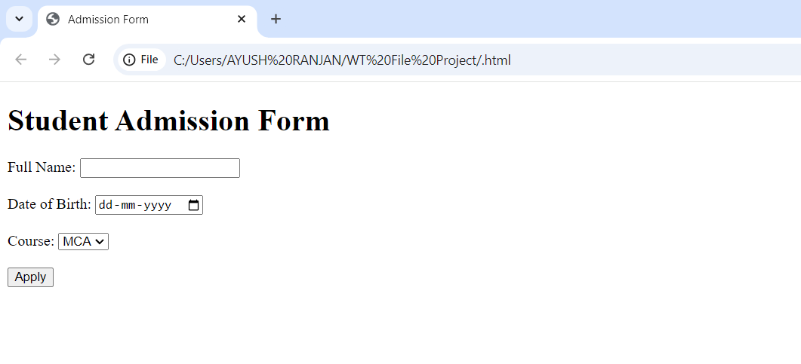

Exercise 20

20. Create a proper home page of your own using any components and styles.

**Code :**

<!DOCTYPE html>

<html>

<head>

<title>Home Page</title>

<style>

body {

font-family: Arial, sans-serif;

}

header {

background-color: #f4f4f4;

padding: 20px;

text-align: center;

}

nav {

margin: 10px;

}

nav a {

margin: 10px;

text-decoration: none;

}

</style>

</head>

<body>

<header>

<h1>Welcome to My Home Page</h1>

</header>

<nav>

<a href="#about">About</a>

<a href="#contact">Contact</a>

</nav>

<p>This is a simple home page design.</p>

</body>

</html>

**Output :** 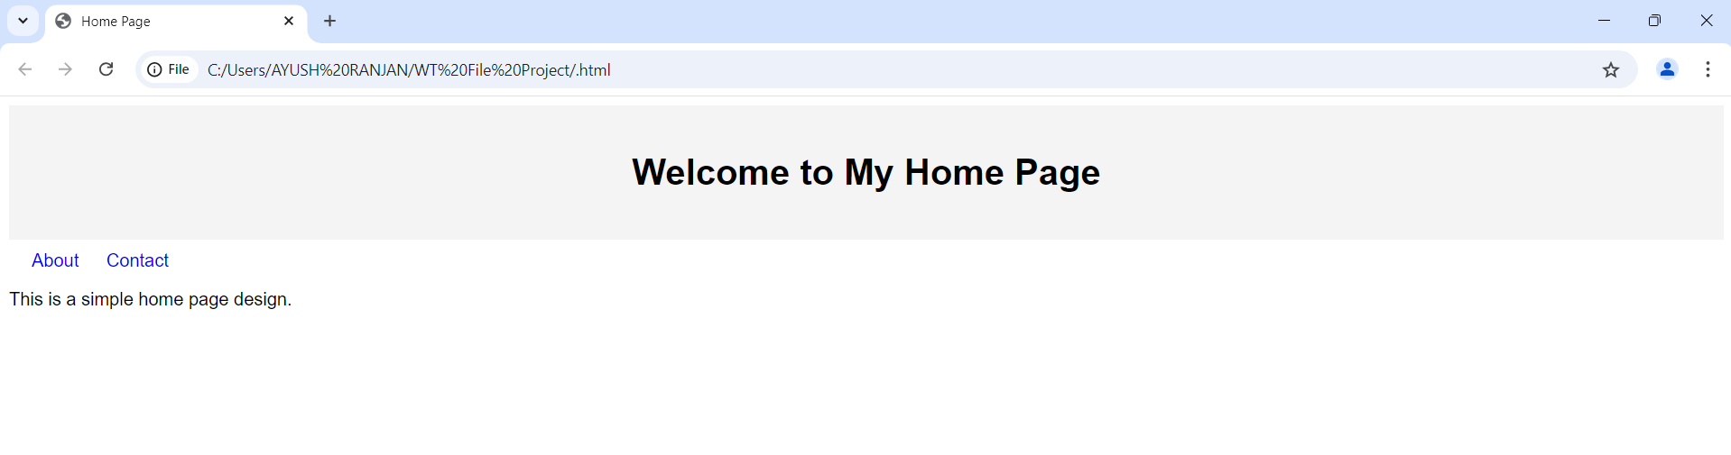

Exercise 21

21. Write HTML code for including Local hyperlinking in a web page.

**Code :**

<!DOCTYPE html>

<html>

<head>

<title>Local Hyperlinking Example</title>

</head>

<body>

<!-- Navigation Links -->

<nav>

<a href="#section1">Go to Section 1</a> |

<a href="#section2">Go to Section 2</a> |

<a href="#section3">Go to Section 3</a>

</nav>

<!-- Content Sections -->

<h2 id="section1">Section 1</h2>

<p>This is the content of Section 1.</p>

<h2 id="section2">Section 2</h2>

<p>This is the content of Section 2.</p>

<h2 id="section3">Section 3</h2>

<p>This is the content of Section 3.</p>

</body>

</html>

**Output :** 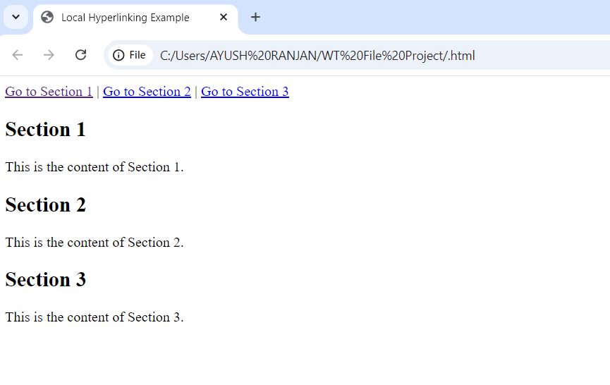

Exercise 22

22. Write HTML code for including Inter hyperlinking in a web page.

**Code :**

**HTML Code**

html

Copy code

<!DOCTYPE html>

<html>

<head>

<title>Inter Hyperlinking Example</title>

</head>

<body>

<h1>Page 1: Welcome</h1>

<p>This is the homepage. Navigate to other pages:</p>

<!-- Links to other pages -->

<a href="page2.html">Go to Page 2</a><br>

<a href="page3.html">Go to Page 3</a>

</body>

</html>

**Page 2 (page2.html):**

html

Copy code

<!DOCTYPE html>

<html>

<head>

<title>Page 2</title>

</head>

<body>

<h1>Page 2: Details</h1>

<p>This is Page 2 content.</p>

<a href="index.html">Back to Home Page</a>

</body>

</html>

**Page 3 (page3.html):**

html

Copy code

<!DOCTYPE html>

<html>

<head>

<title>Page 3</title>

</head>

<body>

<h1>Page 3: Information</h1>

<p>This is Page 3 content.</p>

<a href="index.html">Back to Home Page</a>

</body>

</html>

**Output :**

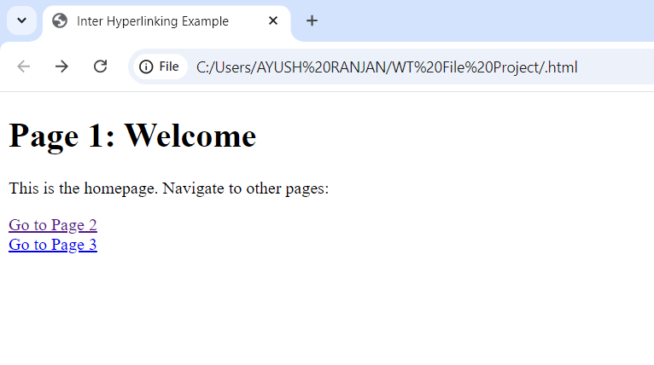

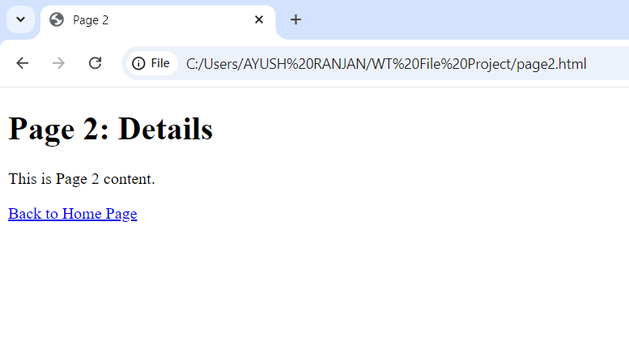

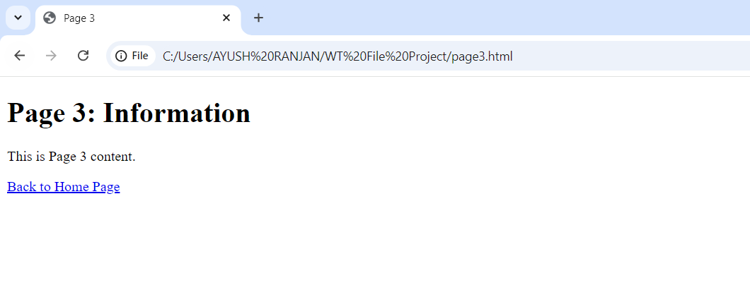

Exercise 23

23. Write HTML code for including External hyperlinking in a web page.

**Code :**

<!DOCTYPE html>

<html>

<head>

<title>External Hyperlinking Example</title>

</head>

<body>

<h1>External Hyperlink Example</h1>

<p>Click the links below to navigate to external websites:</p>

<a href="https://www.google.com" target="_blank">Visit Google</a><br>

<a href="https://www.wikipedia.org" target="_blank">Visit Wikipedia</a>

</body>

</html>

**Output :** 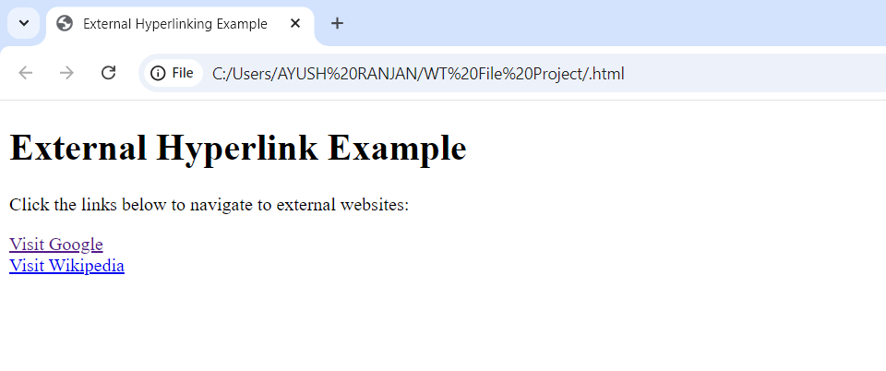

Exercise 24

24. Write code to show External CSS with HTML code.

**Code :**

**1. HTML File (index.html)**

html

Copy code

<!DOCTYPE html>

<html lang="en">

<head>

<meta charset="UTF-8">

<meta name="viewport" content="width=device-width, initial-scale=1.0">

<title>External CSS Example</title>

<!-- Linking the external CSS file -->

<link rel="stylesheet" href="styles.css">

</head>

<body>

<h1>Welcome to My Website</h1>

<p>This is a simple example of using external CSS.</p>

<button>Click Me</button>

</body>

</html>

**2. External CSS File (styles.css)**

css

Copy code

/* External CSS file: styles.css */

/* Styling the body */

body {

font-family: Arial, sans-serif;

background-color: #f0f0f0;

margin: 0;

padding: 20px;

}

/* Styling the h1 tag */

h1 {

color: #4CAF50;

text-align: center;

}

/* Styling the paragraph */

p {

font-size: 1.2rem;

color: #333;

text-align: center;

}

/* Styling the button */

button {

display: block;

margin: 20px auto;

padding: 10px 20px;

background-color: #008CBA;

color: white;

border: none;

border-radius: 5px;

cursor: pointer;

}

button:hover {

background-color: #007B8A;

}

**Output :**

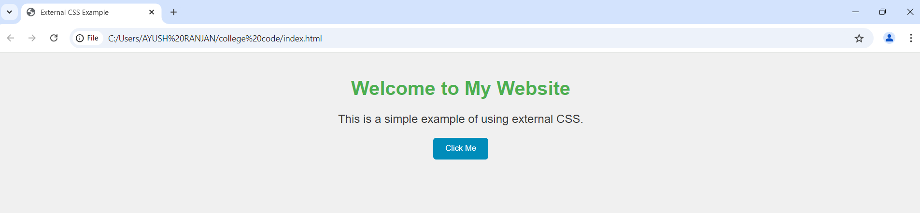

Exercise 25

25. Write code to show Internal CSS with HTML code.

**Code :**

<!DOCTYPE html>

<html>

<head>

    <title>Internal CSS Example</title>

    <style>

        body {

            background-color: lightgray;

            font-family: Arial, sans-serif;

        }

        h1 {

            color: blue;

            text-align: center;

        }

        p {

            color: green;

            font-size: 18px;

        }

    </style>

</head>

<body>

    <h1>Internal CSS </h1>

    <p>This paragraph is styled using internal CSS.</p>

</body>

</html>

**Output :** 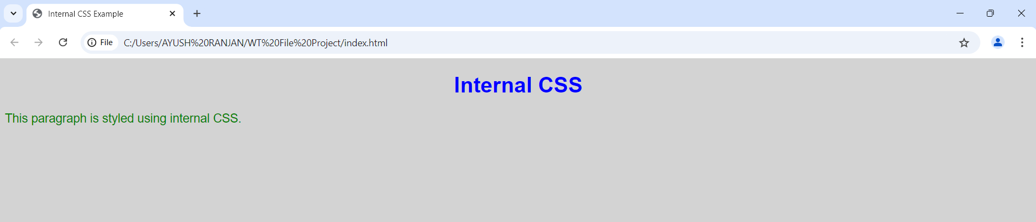

Exercise 26

26. Write code to show Inline CSS with HTML code.

**Code :**

<!DOCTYPE html>

<html>

<head>

    <title>Inline CSS Example</title>

</head>

<body>

    <h1 style="color: red; text-align: center;">This is a heading</h1>

    <p style="color: blue; font-size: 20px;">This is a paragraph with inline CSS.</p>

</body>

</html>

**Output :** 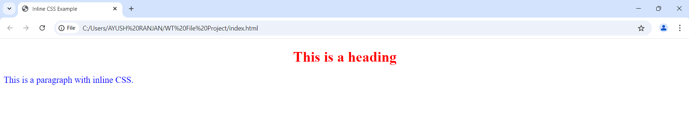

Exercise 27

27. Write a program to add two numbers using form in Javascript.

**Code :**

<!DOCTYPE html>

<html>

<head>

    <title>Add Two Numbers</title>

    <script>

        function addNumbers() {

            let num1 = parseFloat(document.getElementById("num1").value);

            let num2 = parseFloat(document.getElementById("num2").value);

            let sum = num1 + num2;

            document.getElementById("result").textContent = "Sum: " + sum;

        }

    </script>

</head>

<body>

    <form>

        <label>Number 1: </label>

        <input type="number" id="num1"><br><br>

        <label>Number 2: </label>

        <input type="number" id="num2"><br><br>

        <button type="button" onclick="addNumbers()">Add</button>

    </form>

    <p id="result"></p>

</body>

</html>

**Output :** 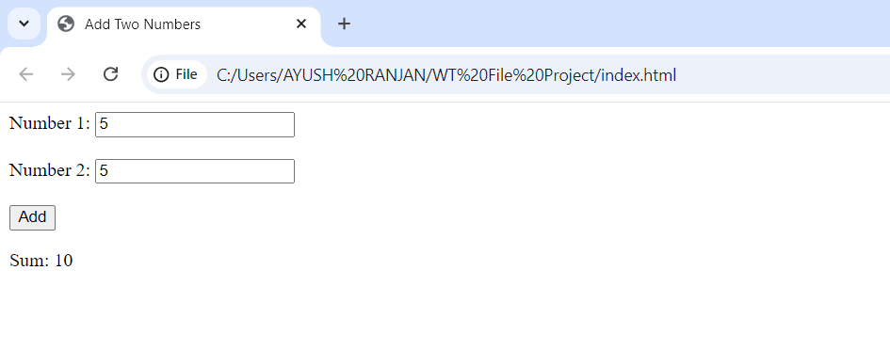

Exercise 28

28. Write a program in Javascript to swap two images using OnmouseOver event.

**Code :**

**Output :**

Exercise 29

29. Write a simple JavaScript program to sort an array.

**Code :**

<!DOCTYPE html>

<html>

<head>

    <title>Sort an Array</title>

    <script>

        function sortArray() {

            // Example array

            let array = [34, 7, 23, 32, 5, 62];

            // Sort the array in ascending order

            array.sort((a, b) => a - b);

            // Display the sorted array

            document.getElementById("result").textContent = "Sorted Array: " + array.join(", ");

        }

    </script>

</head>

<body>

    <h1>Array Sorting Example</h1>

    <p>Click the button below to sort the array:</p>

    <button onclick="sortArray()">Sort Array</button>

    <p id="result"></p>

</body>

</html>

**Output :** 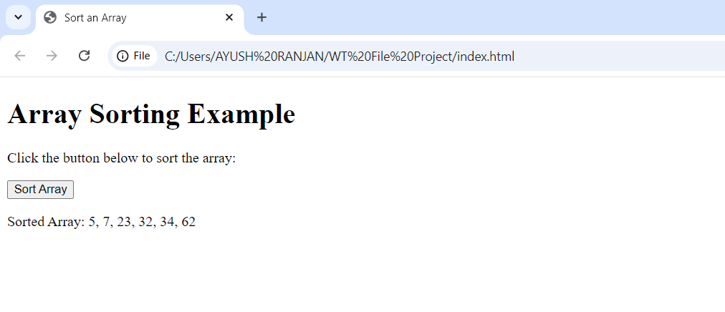

Exercise 30

30. Write a JavaScript program to take as input three numbers from the user. Find the minimum and maximum of the three numbers. Print the following output in BOLD in the following format:

MINIMUM = 2

MAXIMUM = 50

**Code :**

<!DOCTYPE html>

<html>

<head>

    <title>Find Minimum and Maximum</title>

    <script>

        function findMinMax() {

            // Take three numbers as input from the user

            let num1 = parseFloat(prompt("Enter the first number:"));

            let num2 = parseFloat(prompt("Enter the second number:"));

            let num3 = parseFloat(prompt("Enter the third number:"));

            // Validate input

            if (isNaN(num1) || isNaN(num2) || isNaN(num3)) {

                alert("Please enter valid numbers.");

                return;

            }

            // Calculate minimum and maximum

            let min = Math.min(num1, num2, num3);

            let max = Math.max(num1, num2, num3);

            // Display the results in bold format

            document.getElementById("result").innerHTML = `

                <b>MINIMUM = ${min}</b><br>

                <b>MAXIMUM = ${max}</b>

            `;

        }

    </script>

</head>

<body>

    <h1>Find Minimum and Maximum</h1>

    <button onclick="findMinMax()">Find Min and Max</button>

    <div id="result"></div>

</body>

</html>

**Output :**

